**SELENIUM – PRACTICE EXERCISE 02**

**Name:** Vaibhav Agrahari

**Date:** 4th Sep 2024

**Batch Code:** Testing-240

**Employee ID:** 2608111

**Problem Statement 1: WebDriver Basics**

1. Automate the Registration and Login Functionality with Selenium WebDriver

URL: <http://demowebshop.tricentis.com/>

Step 1: Create a TestNG class with 2 Tests:

registrationTest

loginTest

Step 2: Write a selenium test in method name registrationTest to test registration functionality. Test should follow navigation Home> Register to open the registration page.

Step 3: Write a selenium test in method name loginTest to test login functionality. Test should

follow navigation Home>Log in to open the login page.

Step 4: Appropriate priority should be given to execute the Registration Test first followed by the Login Test.

**CODE --**

1. Automate the Search Functionality with Selenium WebDriver

URL: <http://demowebshop.tricentis.com/>

Step 1: Type “Computer” in the search Text box.

Step 2: Click the Search Button.

Step 3: Verify the items displayed in the search results are relevant to the selected item.

**CODE --**

1. Create the Script to Find the High Rating Product and add to Cart Functionality with Selenium WebDriver

URL: <http://demowebshop.tricentis.com/>

Step 1: Type “Computer” in the search Text box and press search.

Step 2: Add the item to cart which is having Highest number of reviews.Step 3: Verify the number of reviews matches with the highest review.

**CODE --**

1. Data Driven Testing with TestNG DataProvider

URL: <http://demowebshop.tricentis.com/>

Step 1: Write a selenium test in method name login Test to test login functionality. Test should follow navigation Home>Log in to open the login page.

Step 2: Perform the data driven testing with multiple test data with their expected result.

Step 3: Follow the below Test data.

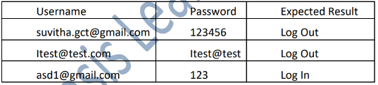

Tip: use @DataProvider annotation

**CODE --**